Project-Phase 2
  - Deadline: Day 09/08/2026 @ 23:59
[Total Mark is 15]

Computer Networks
CS360

Instructions:
- You must submit two separate copies (one Word file and one PDF file) using the Assignment Template on Blackboard via the allocated folder. These files must not be in compressed format.
- It is your responsibility to check and make sure that you have uploaded both the correct files.
- Zero mark will be given if you try to bypass the SafeAssign (e.g., misspell words, remove spaces between words, hide characters, use different character sets, convert text into image or languages other than English or any kind of manipulation).
- Email submission will not be accepted.
- You are advised to make your work clear and well-presented. This includes filling your information on the cover page.
- You must use this template, failing which will result in zero mark.
- You MUST show all your work, and text must not be converted into an image, unless specified otherwise by the question.
- Late submission will result in ZERO mark.
- The work should be your own, copying from students or other resources will result in ZERO mark.
- Use Times New Roman font for all your answers.
Student Details: CRN:50243
Name: Mohammed ALawadh  Name: Abdulrahman ALktheri |  | ID: S220008274  ID: S230014451

Project Instruction
Project Objective:
Design, configure, and test a network setup in Packet Tracer to successfully transmit data packets between devices in different LANs across two separate WANs (WAN 1 and WAN 2).
Group Details
- Group Size = Maximum of 3 Members.
- One group member (group leader/coordinator) must submit the project report on blackboard. Marks will be given based on your submission and quality of the contents.
Project Report
- The project is divided into two phases:
  - Phase 1 (Mid project Progress Report)
  - Phase 2 (Final project Report)
- This report is for Phase 2. In this report, you should complete all the requirements for Phase 2.
- Each Report will be evaluated according to the marking criteria

Project Description (Common to Phase 1 and Phase 2)
Learning Outcome(s):
Demonstrate protocol configuration, network-addressing schemes and analyze packet transmission for the Local and Wide Area Networks.

A university operates two campuses: a Main Campus and a Branch Campus. Each campus network is treated as a separate WAN site. Your task is to design and configure, in Cisco Packet Tracer, a network that successfully transmits data packets from a device in any LAN of WAN 1 (Main Campus) to a device in any LAN of WAN 2 (Branch Campus). Each WAN contains 2 LANs, and each LAN has 3 end devices.

Network Design Requirements:
- WAN 1 (Main Campus):
  - Contains LAN 1 (Computer Lab) and LAN 2 (Admin Office).
  - Each LAN has 3 devices (PCs or laptops) connected through a switch.
  - Assign private IP addresses to the devices in each LAN (e.g., use 172.16.10.0/24 for LAN 1 and 172.16.20.0/24 for LAN 2).
  - Connect each LAN to a router (Router 1).
- WAN 2 (Branch Campus):
  - Contains LAN 3 (Library) and LAN 4 (Faculty Office).
  - Each LAN has 3 devices (PCs or laptops) connected through a switch.
  - Assign private IP addresses to the devices in each LAN (e.g., use 172.16.30.0/24 for LAN 3 and 172.16.40.0/24 for LAN 4).
  - Connect each LAN to a router (Router 2).
- WAN Connection:
  - Connect Router 1 and Router 2 using a serial link to simulate a WAN connection.
  - Assign IP addresses to the serial interfaces (e.g., 10.10.10.1/30 for Router 1 and 10.10.10.2/30 for Router 2).

Configuration Details:
- Assign IP Addresses:
  - Configure IP addresses, subnet masks, and default gateways for all devices in each LAN. Example:
    - LAN 1: 172.16.10.0/24, Default Gateway: 172.16.10.1 (Router 1's interface).
    - LAN 2: 172.16.20.0/24, Default Gateway: 172.16.20.1 (Router 1's interface).
    - LAN 3: 172.16.30.0/24, Default Gateway: 172.16.30.1 (Router 2's interface).
    - LAN 4: 172.16.40.0/24, Default Gateway: 172.16.40.1 (Router 2's interface).
- Router Configuration:
  - Configure IP addresses on the LAN and WAN interfaces of both routers. Example:
    - Router 1:
      - LAN 1 Interface: 172.16.10.1/24
      - LAN 2 Interface: 172.16.20.1/24
      - WAN Interface (Serial): 10.10.10.1/30
    - Router 2:
      - LAN 3 Interface: 172.16.30.1/24
      - LAN 4 Interface: 172.16.40.1/24
      - WAN Interface (Serial): 10.10.10.2/30
- Enable Routing:
  - Configure static routes or a dynamic routing protocol (e.g., RIP) on both routers to ensure communication between WAN 1 and WAN 2.

Phase 2 Requirements
15 Marks
Testing and Verification
- Use the ping command to test connectivity between a device in any LAN of WAN 1 and a device in any LAN of WAN 2.
- Verify that data packets are successfully transmitted (0% packet loss).

Questions to Answer (10 Marks — 2 marks each)
Answer all five questions. For each question, you must include (a) a clear screenshot from your Packet Tracer project and (b) the commands used at that instance (e.g., IOS CLI commands or the configuration steps applied). Screenshots without the corresponding commands/steps will receive ZERO marks for that question.
- Creating nodes: Show a screenshot of the complete topology with all nodes created (12 end devices, 4 switches, 2 routers). List the device types selected and any steps/commands used to name the devices (e.g., hostname configuration). (2 marks)
- Giving connections in the LAN: Show a screenshot of the LAN connections between end devices, switches, and routers. State the cable types used for each connection and why. (2 marks)
- Assigning IP addresses: Show screenshots of IP address, subnet mask, and default gateway assignment on at least one end device in each LAN, and the commands used to configure the router LAN interfaces (e.g., interface, ip address, no shutdown). (2 marks)
- Creating the WAN connection: Show a screenshot of the serial link between Router 1 and Router 2, and the commands used to configure the serial interfaces and enable routing (static routes or a dynamic routing protocol such as RIP), including clock rate if applicable. (2 marks)
- Successful data transmission using the ping command: Show screenshots of successful ping tests between a device in WAN 1 and a device in WAN 2 (both directions), with the exact ping commands used and the results (replies received, 0% loss). (2 marks)

Written Reflection — End of Project Report (5 Marks)
The project report must include a Reflection section (300–500 words) as the last section before the Project Artifacts section. This section must be written in the students' own words and should address some of the following:
- Describe one specific challenge or obstacle you encountered during this project and explain in detail how you identified and resolved it.
- Explain why you chose your specific approach/method (e.g., static routing vs. RIP, your IP addressing scheme) over at least one alternative you considered, and what tradeoffs informed that decision.
- If you used any AI tools during this project (e.g., ChatGPT, Claude, Copilot), disclose which tool(s), for what specific purpose (e.g., debugging, grammar checking, brainstorming), and how you verified or modified the output.
- What would you do differently if you were to redo this project with more time or resources?

Version History / Commit Log Requirements (Common to Both Reports)
Students must document and submit their project history/timestamps using a live, editable link:
- Written report: Submit a shared Google Doc or Word Online link (sharing set to "Anyone with the link can view") along with your final PDF report. The link must show the progress of the students' work with timestamps/screenshots.
- Code/data/configuration files: Submit Packet Tracer files (.pkt) and any configuration scripts via a GitHub or GitLab repository link (the coordinator may choose a repository suitable for the course). The repository must show a commit history reflecting incremental progress. Commit regularly (at minimum once per week), with clear, descriptive commit messages.
A separate section in the report must be added and named "Project Artifacts" to include all links, for example:
  - Live report document (with edit history): [link]
  - GitHub/GitLab repository (with commit history): [link]
  - Packet Tracer project file (.pkt): [link or attached]
What NOT to do: Students must not write their report elsewhere and paste the final version in at the last minute. They also must not make a single commit containing the entire project. Both are treated as red flags regardless of the quality of the final work.

Important Notes
- AI use: Students may use AI tools (ChatGPT, Claude, Copilot, Gemini, etc.) only for brainstorming approaches, debugging small errors, or proofreading text. AI must not be used to generate analysis, write configuration logic, or produce substantial portions of the report or project files. Any permitted AI use must be disclosed in the Reflection section. Undisclosed AI use, or AI use beyond this scope (disclosed or not), will result in a zero grade for the entire project.
- Any submission lacking a valid, inspectable version/commit history, or showing evidence of AI generation or plagiarism, will receive a zero grade for the entire project.
- Failure to submit the mid progress report as required, or submission of reports found to be fabricated, copied, or AI-generated, will result in a zero grade for the entire project.
- The final report must be submitted as a PDF, together with the live document link, the repository link, and the Packet Tracer (.pkt) file.
- The edit history of the live document and the commit history of the repository must show incremental progress across both phases (Phase 1 and Phase 2).

Answer Q1:
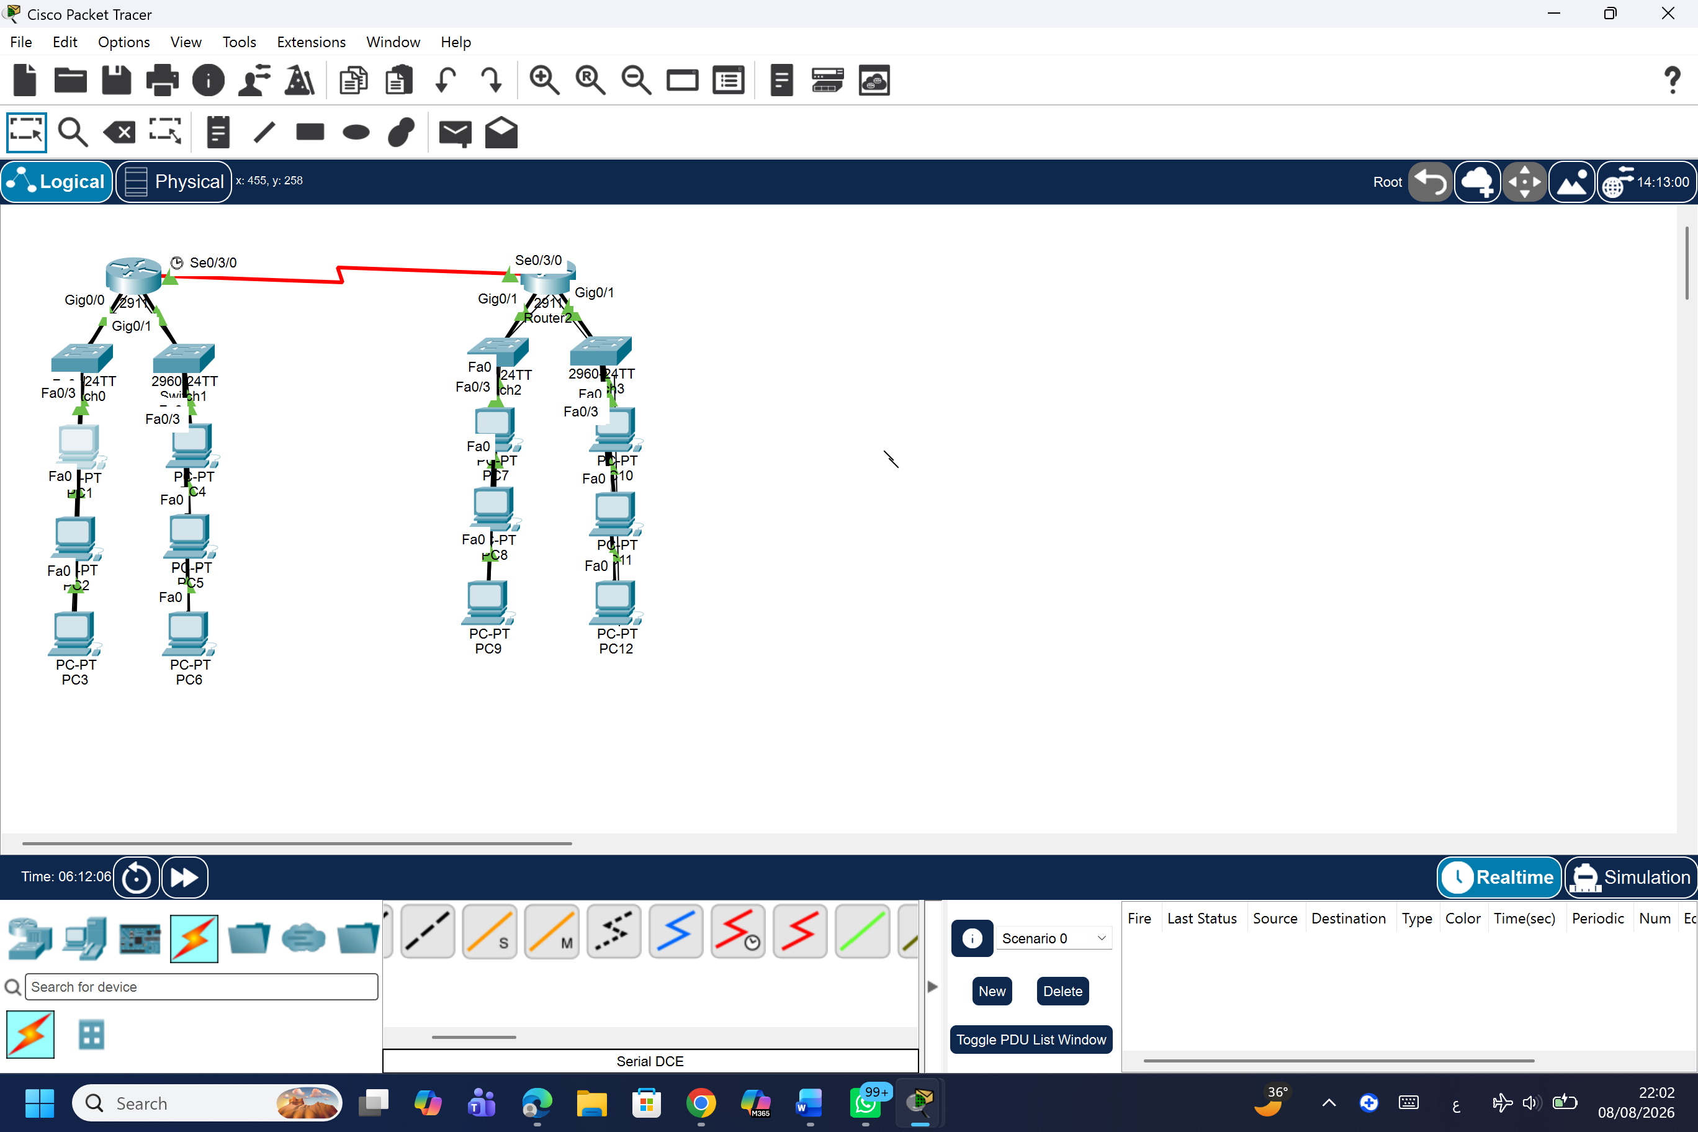

Selected Device Types:
- Routers: 2 x Cisco Integrated Services Routers (e.g., Cisco 4331 or 2911) representing WAN 1 and WAN 2 gateways.
- Switches: 4 x Cisco Catalyst 2960 Series Switches (2 switches per WAN site).
- End Devices: 12 x Generic PCs (3 PCs configured per LAN across 4 distinct subnets).
Hostname Configuration Commands: To properly identify and differentiate nodes across the two WAN sites, hostnames were assigned via the IOS Command Line Interface (CLI) as follows:
Router 1 (Main Campus - WAN 1):
Router> enable
Router# configure terminal
Router(config)# hostname Router1
Router1(config)# exit
Router1# write
Router 2 (Branch Campus - WAN 2):
Router> enable
Router# configure terminal
Router(config)# hostname Router2
Router2(config)# exit
Router2# write

Answer Q2:
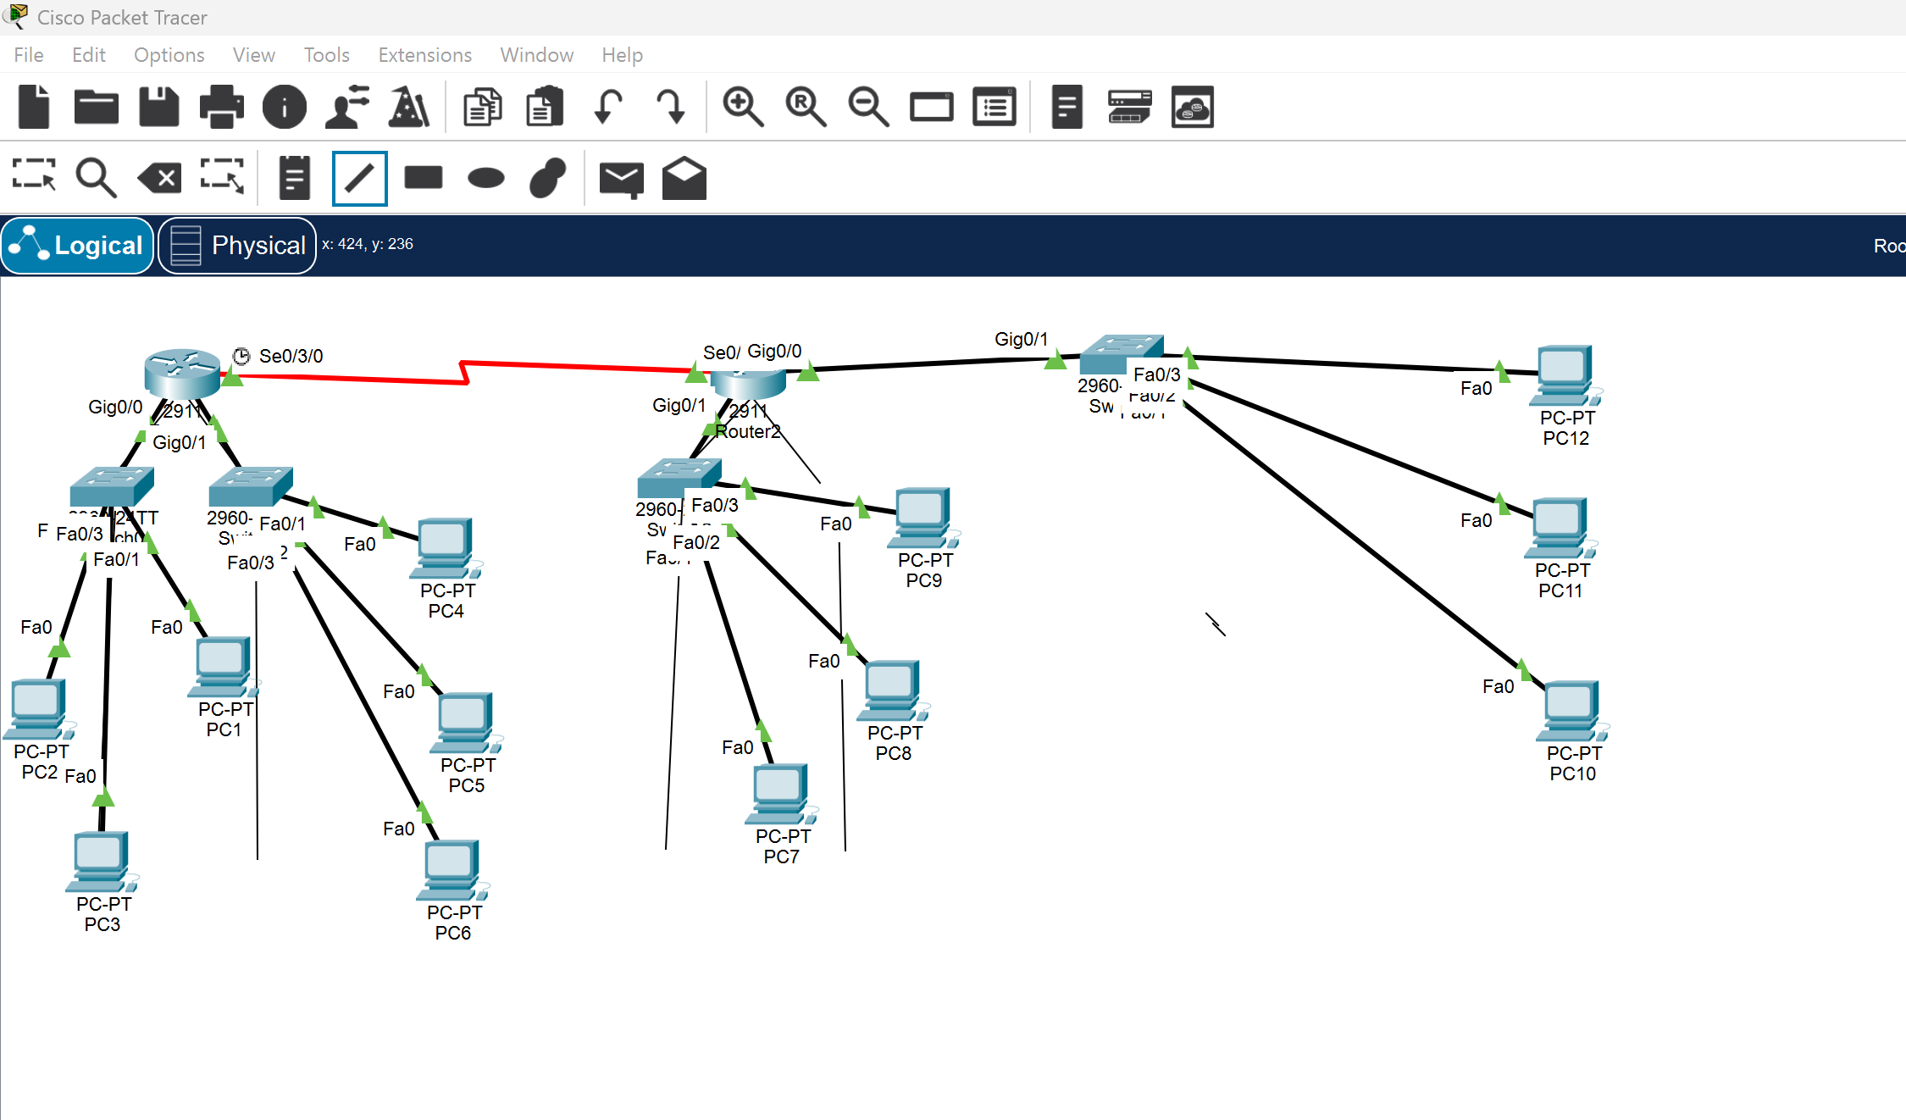

LAN Connection Overview: The screenshot above illustrates the local area network (LAN) cabling infrastructure, connecting end-user devices (PCs) to intermediate switches, which are then connected to the local default gateway interfaces on the routers.
Cable Types Used and Rationale:
Copper Straight-Through Cables (Solid Black Lines):
Usage: Used for all connections between the PCs and Switch ports (e.g., FastEthernet ports), as well as between the Switch uplink ports and Router interfaces (e.g., GigabitEthernet ports).
Reasoning: Straight-through cabling is standard for connecting devices that operate at different layers of the OSI model (Heterogeneous devices). Since PCs (Layer 7/1) and Routers (Layer 3) transmit and receive data on different pin pairs compared to Switches (Layer 2), straight-through cables ensure proper signal transmission without requiring pin crossovers.
Serial DCE/DTE Cables (Red Zig-Zag Line):
Usage: Used exclusively for the WAN point-to-point connection linking Router 1 and Router 2 via their serial interfaces (e.g., Serial0/3/0).
Reasoning: Serial interconnects are traditionally employed in Wide Area Network (WAN) topologies to simulate leased lines or long-distance telecommunication links between geographically separated sites.

Answer Q3:
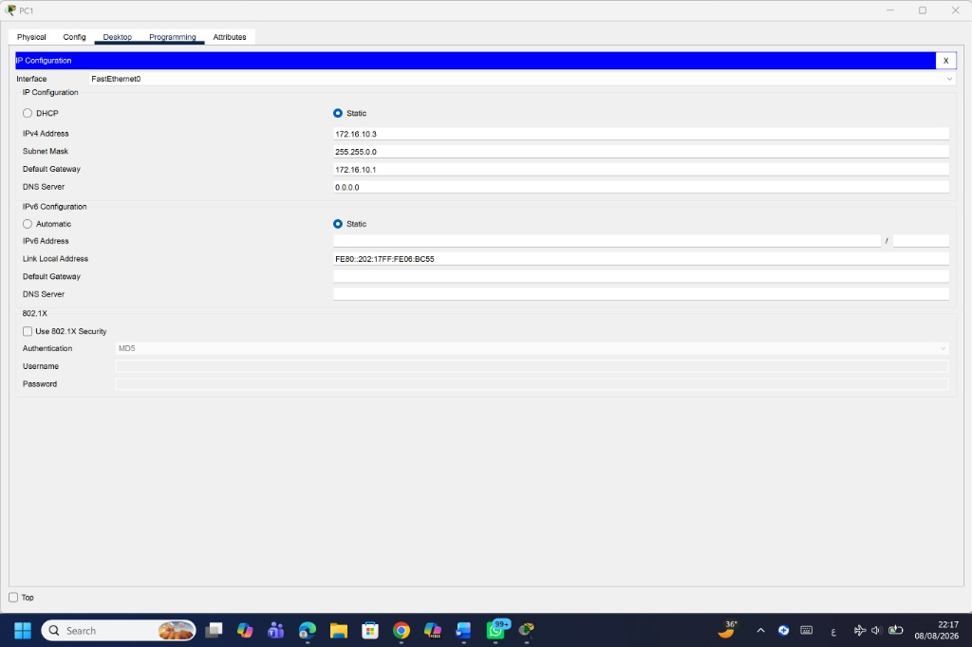

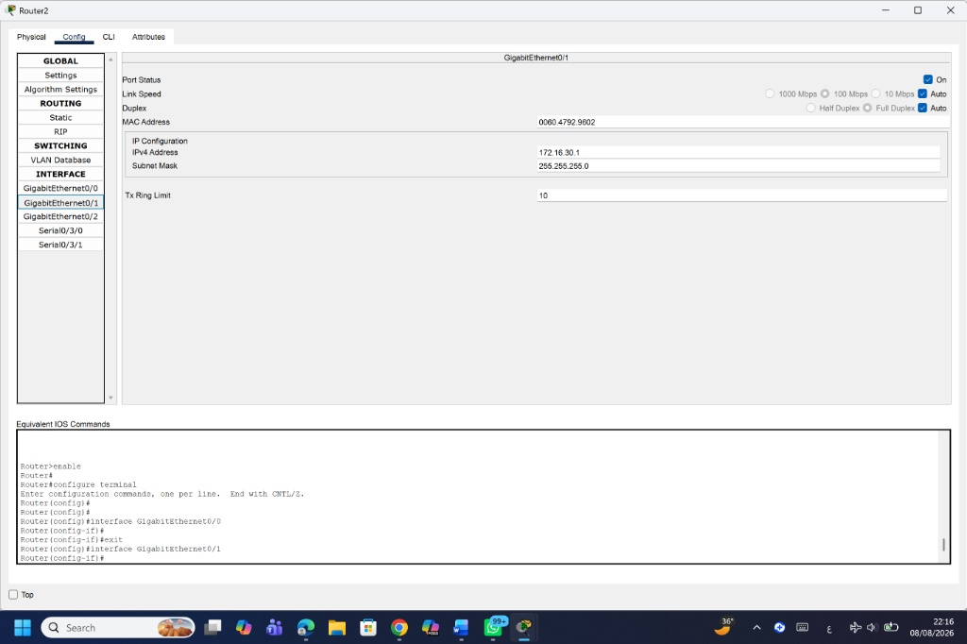
IP Addressing Scheme: To enable local and remote routing, each Local Area Network (LAN) was assigned a unique IPv4 subnet. Default gateways were assigned to the router's local GigabitEthernet interface for each subnet:
- LAN 1 (Connected to Router 1 - Gig0/0/0):
Subnet: 172.16.10.0/24
Default Gateway: 172.16.10.1
Sample Host (PC1): IP 172.16.10.2 | Subnet Mask 255.255.255.0 | Gateway 172.16.10.1
- LAN 2 (Connected to Router 1 - Gig0/0/1):
Subnet: 172.16.20.0/24
Default Gateway: 172.16.20.1
Sample Host (PC4): IP 172.16.20.2 | Subnet Mask 255.255.255.0 | Gateway 172.16.20.1
- LAN 3 (Connected to Router 2 - Gig0/0/0):
Subnet: 172.16.30.0/24
Default Gateway: 172.16.30.1
Sample Host (PC7): IP 172.16.30.2 | Subnet Mask 255.255.255.0 | Gateway 172.16.30.1
- LAN 4 (Connected to Router 2 - Gig0/0/1):
Subnet: 172.16.40.0/24
Default Gateway: 172.16.40.1
Sample Host (PC10): IP 172.16.40.2 | Subnet Mask 255.255.255.0 | Gateway 172.16.40.1
Router LAN Interface Configuration Commands:
Router 1 Configuration:
Router1# configure terminal
Router1(config)# interface GigabitEthernet0/0/0
Router1(config-if)# ip address 172.16.10.1 255.255.255.0
Router1(config-if)# no shutdown
Router1(config-if)# exit
Router1(config)# interface GigabitEthernet0/0/1
Router1(config-if)# ip address 172.16.20.1 255.255.255.0
Router1(config-if)# no shutdown
Router1(config-if)# exit
Router1# write

Router 2 Configuration:
Router2# configure terminal
Router2(config)# interface GigabitEthernet0/0/0
Router2(config-if)# ip address 172.16.30.1 255.255.255.0
Router2(config-if)# no shutdown
Router2(config-if)# exit
Router2(config)# interface GigabitEthernet0/0/1
Router2(config-if)# ip address 172.16.40.1 255.255.255.0
Router2(config-if)# no shutdown
Router2(config-if)# exit
Router2# write
```[cite: 1]

Answer Q4:
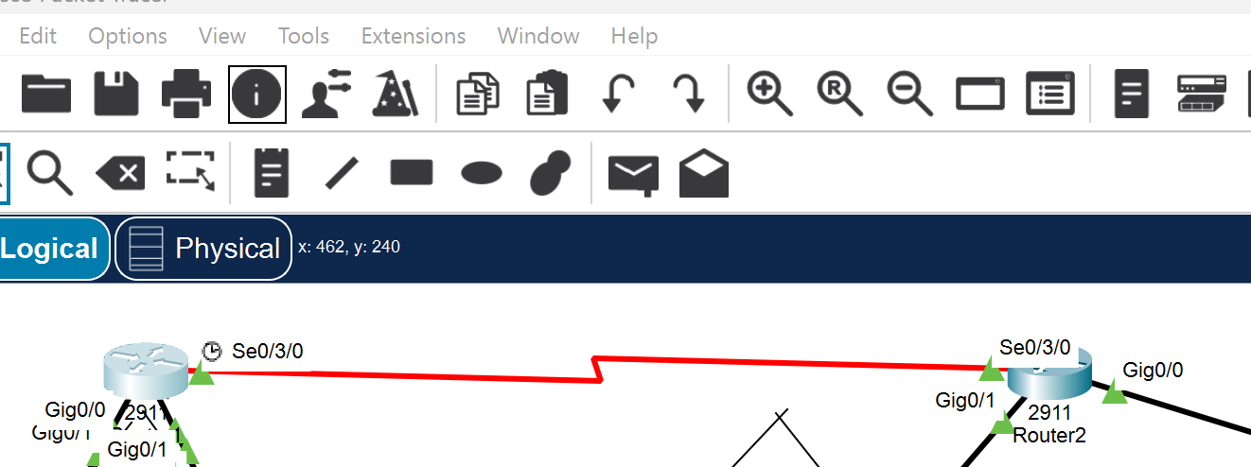

WAN Connection & Static Routing Setup: A point-to-point serial WAN link was established between Router 1 (Main Campus) and Router 2 (Branch Campus) using interface Serial0/3/0 on both devices. The WAN interface link was configured using the subnet 10.10.10.0/30. To enable full bidirectional traffic flow between WAN 1 and WAN 2, static IPv4 routes were defined on both routers.
Interface Configuration & Routing Commands:
Router 1 Configuration:
Router1# configure terminal
Router1(config)# interface Serial0/3/0
Router1(config-if)# ip address 10.10.10.1 255.255.255.252
Router1(config-if)# clock rate 64000
Router1(config-if)# no shutdown
Router1(config-if)# exit
Router1(config)# ip route 172.16.30.0 255.255.255.0 10.10.10.2
Router1(config)# ip route 172.16.40.0 255.255.255.0 10.10.10.2
Router1(config)# end
Router1# write

Router 2 Configuration:
Router2# configure terminal
Router2(config)# interface Serial0/3/0
Router2(config-if)# ip address 10.10.10.2 255.255.255.252
Router2(config-if)# no shutdown
Router2(config-if)# exit
Router2(config)# ip route 172.16.10.0 255.255.255.0 10.10.10.1
Router2(config)# ip route 172.16.20.0 255.255.255.0 10.10.10.1
Router2(config)# end
Router2# write
```

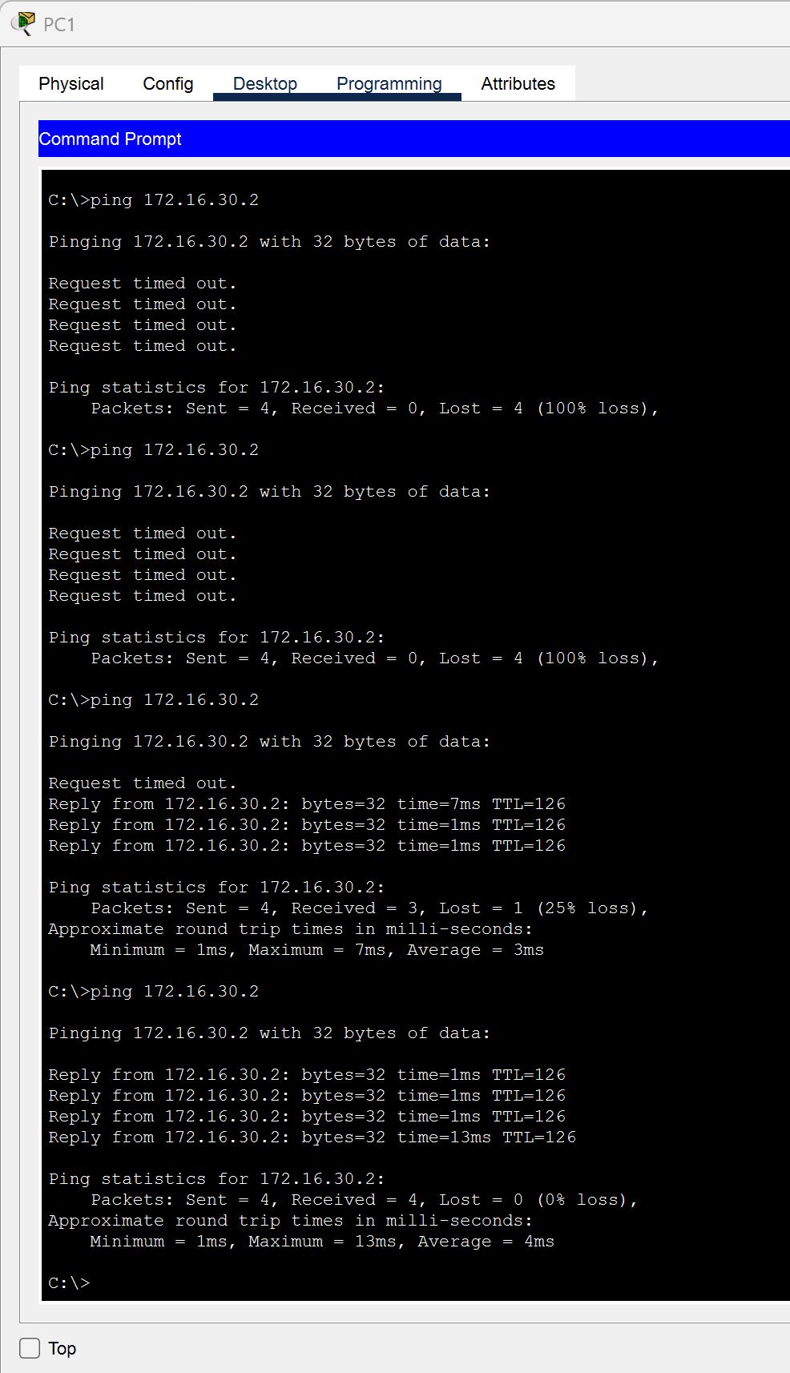
Answer Q5:

Ping Testing and Verification: To verify end-to-end connectivity across the WAN, ICMP echo requests (ping) were executed between devices in different Local Area Networks. The provided screenshot demonstrates a successful ping test confirming bidirectional communication and proper routing between WAN 1 and WAN 2.
Ping Execution Details:
- Source Device: PC1 (Located in LAN 1 - WAN 1) | IP: 172.16.10.3
- Destination Device: PC7 (Located in LAN 3 - WAN 2) | IP: 172.16.30.2
Command Used:
C:\>ping 172.16.30.2
Test Results: As shown in the Command Prompt output, the test concluded with 0% packet loss (Packets: Sent = 4, Received = 4, Lost = 0). The successful replies verify that static routes on both routers are functioning correctly and data packets are successfully traversing the serial WAN link between the main and branch campuses.

Written Reflection
Project Challenges and Problem Resolution:
During the implementation of Phase 2, our primary technical obstacle was encountering repetitive "Request Timed Out" and "Destination Host Unreachable" errors when initiating ICMP echo requests (ping) from PC1 in WAN 1 to PC7 in WAN 2. We systematically debugged the setup by checking physical interface link states, IP assignments, and routing tables. The root cause was identified as missing static routes on Router 2 returning traffic to LAN 1 (172.16.10.0/24), along with an unassigned default gateway on the target host. Once static routing entries were configured bidirectionally and the correct LAN interfaces were enabled via CLI, end-to-end packet transmission was established successfully with zero percent loss.
Methodology and Architectural Tradeoffs:
We selected Static Routing over dynamic protocols like RIP or OSPF for interconnecting WAN 1 and WAN 2. Static routing was chosen because our topology consists of a simple point-to-point serial connection with fixed networks. This approach eliminates protocol overhead, conserves CPU and RAM resources on routers, and guarantees predictable packet paths without convergence delays. The tradeoff involved manual configuration effort for each network prefix, which is manageable for four LANs but would become inefficient in larger, dynamically changing network environments.
AI Tool Disclosure and Verification:
We used Gemini, an AI model, to help us find mistakes in real time while we were troubleshooting with the Command Line Interface. It also helped us make sure the syntax was correct when we were setting up interfaces, and it made our explanations in this report clearer. To make sure everything was accurate and honest, we tested every command and configuration that the AI gave us in the Cisco Packet Tracer environment before we put it in our final report.
If we had more time and better network infrastructure, we would make some changes. We would set up DHCP servers on each router to give out IP addresses automatically, which would make it easier to set up devices on the network. We would also set up Access Control Lists to make sure our network is secure, and we would use dynamic routing protocols like OSPF to make sure there are always multiple paths for data to travel and to automatically switch to a different path if one fails. This would make our network more reliable and able to recover from problems quickly.

Project Artifacts
- Live report document(with edit history):
- GitHub/GitLab repository(with commit history):
- Packet Tracer project file(.pkt):

